# CS 255 System Design Document Template

This template lays out all the different sections that you need to complete for Project Two. Each section has guidance to prompt your thinking. You will need to continually reference the interview transcript as you work to make sure that you are addressing your client’s needs. There is no required length for the final document. Instead the goal is to complete each section based on what your client’s needs are. Remove this note when you are finished, and replace all bracketed text with the relevant information.

## UML Diagrams

### UML Use Case Diagram

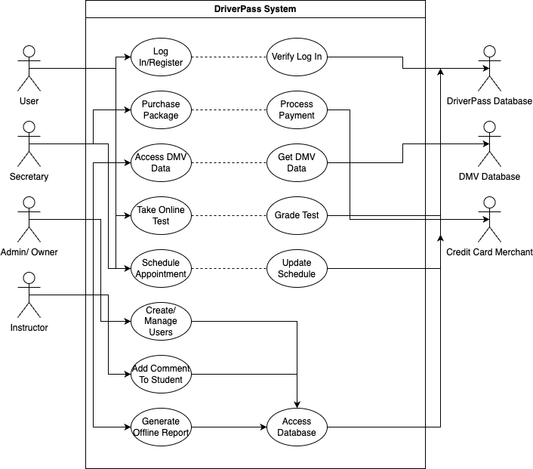

### UML Activity Diagrams

### UML Sequence Diagram

### UML Class Diagram

## Diagram Description automatically generatedTechnical Requirements

*Hardware:*

* *Dedicated Server.*
* *Server for backup and redundancy.*
* *Enterprise network switch/ router.*
* *UPS in case of power loss.*
* *Stable Internet Connection.*
* *Storage for database and website.*
* *Computer or mobile device to access website.*
* *Firewall to protect website and database.*

*Software:*

* *Linux server (LTS release) to host database and website.*
* *SQL server for database connection.*
* *Backup server to backup database and website.*
* *Firewall for data protection.*
* *Malware/ Virus software for security.*

*Infrastructure:*

* *Data center to host web application and associated components.*
* *Data center that is based in United States.*
* *Fiber Optic connection.*
* *Should be centrally located for best connectivity and reliability.*